**Applicazioni per Dispositivi Mobili**

**A.A. 2020/2021**

**myBus**

**Design documentation[1],[2]**

|  |  |  |
| --- | --- | --- |
| **Team Members[3]** | | |
| **Name** | **Student Number** | **E-mail address** |
| **Federico Raschiatore** | *260607* | *federico.raschiatore@student.univaq.it* |
| Paolo Attardi | *259185* | [*paolo.attardi@student.univaq.it*](mailto:paolo.attardi@student.univaq.it) |
| Piero Marraffa | *261642* | *piero.marraffa@student.univaq.it* |
| Gabriele Giusti | *261637* | *gabriele.giusti@student.univaq.it* |
|  |  |  |

Strategy

# Product Objectives

# Business goals

# Product Overview

Very brief overview of the app

# Competitors

Describe possible competitors

**User Needs**

**Needs & goals**

Describe the NEEDS that you want to fill with your app

Describe the main GOALS your app allows users to achieve

(If relevant) Divide user needs through USER SEGMENTATION

# User Research

Describe

# Personas

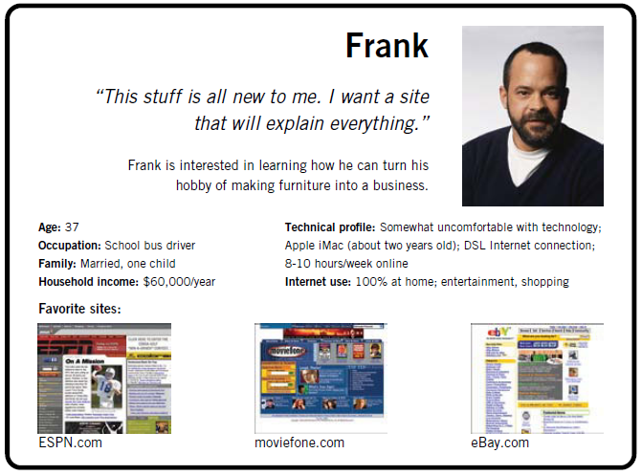

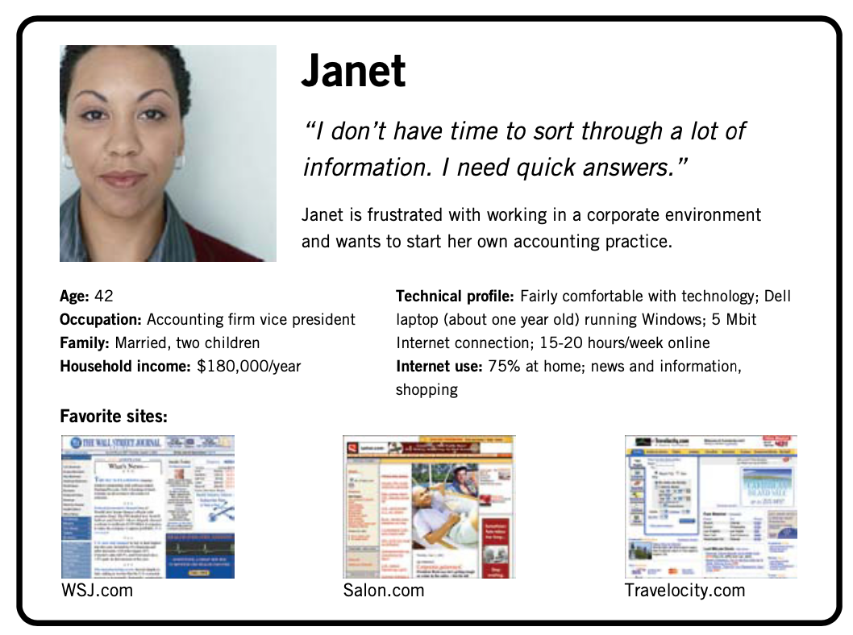

Scope

**Features**

REMOVE THE DESCRIPTION

Provide a list of all the features of your app.

**Other requirements**

REMOVE THE DESCRIPTION

Provide a list of other requirements (not implicitly included in the features) of your app (for instance, branding requirements, technical requirements, …).

**Scenarios**

REMOVE THE DESCRIPTION

It is a short, simple narrative describing how a persona might go about trying to fulfill one of those user needs. By imagining the process our users might go through, we can come up with potential requirements to help meet their needs. (One for persona)

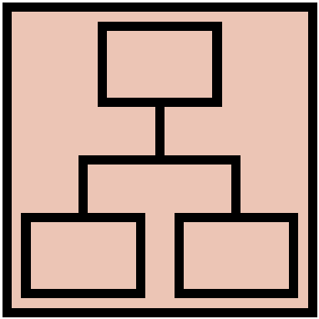Structure

# Navigation model

REMOVE THE DESCRIPTION

Navigation model of your app.

# Data model

REMOVE THE DESCRIPTION

UML Class diagram that represents the data model of the app containing entities and relationships between them. Entities and relationships derive from the functionality and scenarios described in the previous chapter.

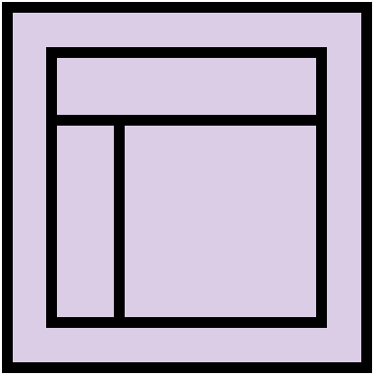Skeleton

REMOVE THE DESCRIPTION

Lo-Fi Wireframes of your app. In this phase you have to create a **complete wireframe** representing all the views described in the navigation model.

Also, for each LO-FI wireframe give a brief description and highlight the design principles used and the design patterns.

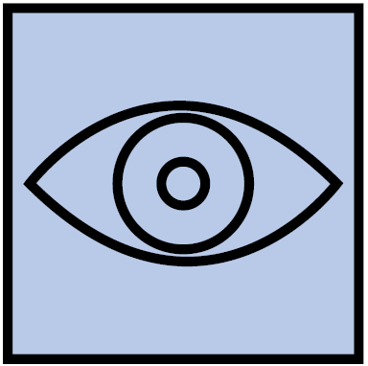Surface

REMOVE THE DESCRIPTION

Description of the relevant choices you made about the layout and color palette, fonts, icons, etc.

Provide a Hi-Fi Wireframes of a **single (or two) view** of your app. Please choose a representative view to show here.

1. REMOVE THE FOOTNOTE: The max length of this document is 20 pages
2. REMOVE THE FOOTNOTE: The structure of this document is fixed, it cannot be changed in any way
3. REMOVE THE FOOTNOTE: The team leader is listed as first member in this table